EXP 01

**Create a simple cloud software application for Flight Reservation System using any Cloud Service Provider to demonstrate SaaS include the necessary fields such as one-way, round trip, From, to, Departure, Departure, Travelers & Class, Fare Type, International and Domestic Flights etc**.

STEP 1: Sign in to the zoho.com and click the creator option

STEP 2: After enter into the creator click the create solution

STEP 3: To create the application by select the application

STEP 4: After selection the application to create the new component form

STEP 5: Click and open the scratch from the form

STEP 6: Enter the name of the form to crate the form

STEP 7: choose any form of template to create the page form

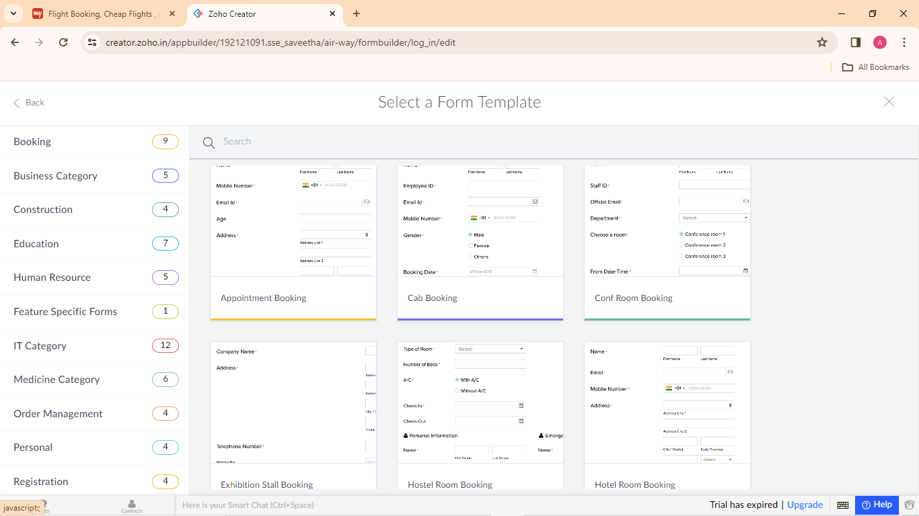

STEP 8: To create the form pages of the application by basic fields

